W1 – Sequence Models - Recurrent Neural Networks
In the first week of sequence models we learned the concept of the recurrent neural networks which are very effective for Natural Language Processing and other sequence tasks because they have "memory". They can read inputs such as words one at a time and remember some information/context through the hidden layer activations that get passed from one time-step to the next.
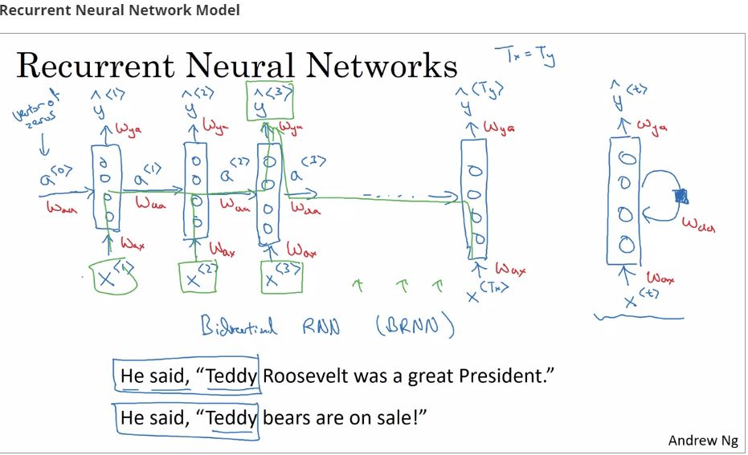

There are different types of RNNS:
-there is one-to-one
-one-to-many: for example, a music generation or sequenced generation
-many-to-one: for example, sentiment classification Where you might want to read as input all the text with a movie review. And then, try to figure out that they liked the movie or not.
-many-to-many for example, name entity recognition
- another version of many-to-many, where for applications like machine translation, Tx and Ty no longer have to be the same.

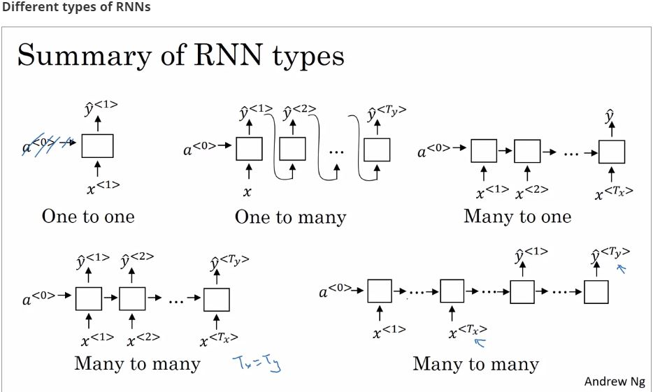

RNNs tend not to be very good at capturing long-range dependencies due to the problem of the vanishing gradients
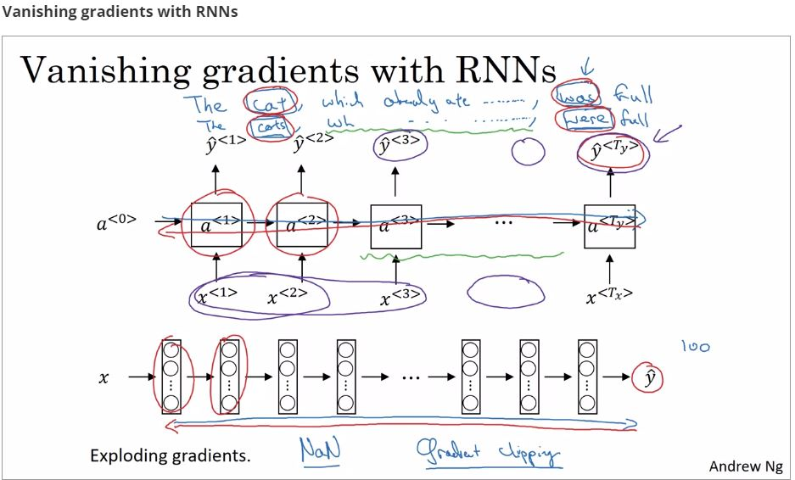
There are different types of RNNS, for example we have the unidirectional RNN which take information from the past to process later inputs. We also have the bidirectional RNN which can take context from both the past and the future.
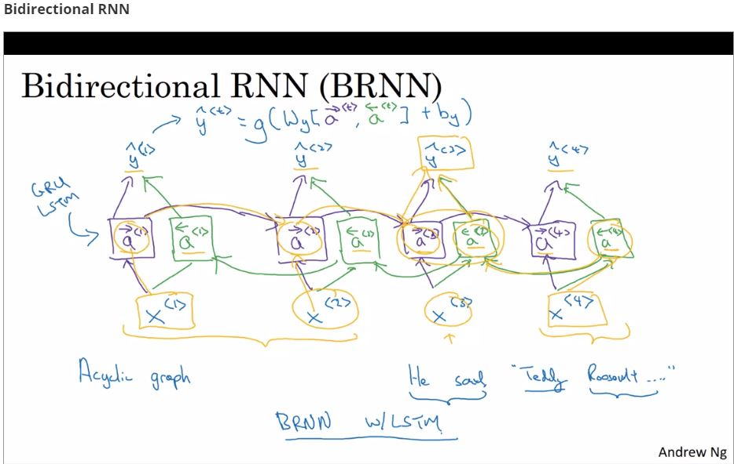

We also get now how to build a deeper RNNs to perform more complex functions
